*** Addlestone and District***

***Scottish Society***

***A recital by***

***Margaret Watson and her Golden Harp***

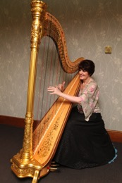

***8.00pm on Wednesday 13th October 2021***

***at St Mary’s Church Hall, Byfleet***

***Family & friends welcome***

***Enquiries to: Wendy Broadfoot:* 01932 848089**